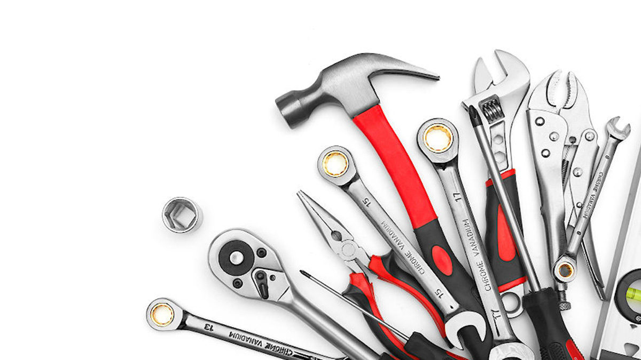
Professor:James Stanworth
Presented By:S1163001 Sam S1163033 Jason S1163034 Waiting S1163035 Cas S1163046 Sean

PRODUCT:SCREWDIVER
TARGET COUNTRY:VIETNAM

Final Project Group 1 DAPU
INTERNATIONAL
MARKETING

Segment 1
● Geographic: Humid climate 1
● Occupation: Amateur vs Professional 2
● Wage range:Low-income 3
The following picture is 「2022 economic class household distribution in Vietnam」 3
3
Product 4
● Anti-slip material 4
Given the high humidity levels, we have opted for non-slip handles to facilitate better force application. The handles are made from 3M™ Gripping Material GM530, which offers superior anti-slip properties even in wet or oily environments. This material is soft to the touch, avoiding any roughness or irritation, and possesses good elasticity, allowing it to closely adhere to curved surfaces. These features ensure a secure grip, enhancing both safety and efficiency during use. 4
● Magnetic front-end 4
● High-carbon steel 4
Pricing 4
● Penetration pricing 4
● Pricing build strategy 5
Position 5
● Product Positioning 5
● Position map 5
Promotion 6
● Channels 6
Service support – 3Ps 6
● Service 6
● Service added value 7
Conclusion 7
Reference 8

Segment

Geographic: Humid climate
Vietnam is geographically located in Southeast Asia, and the climate is mostly humid.So we thought we could make some changes to the material on the handle.
Vietnam's climate, here's the information about two important cities: Hanoi and Ho Chi Ming City. Hanoi, located in the northern part of the country, experiences a subtropical climate with distinct four seasons. On the other hand, Ho Chi Ming City has a tropical climate characterized by wet and dry seasons, without distinct seasons as seen in Hanoi
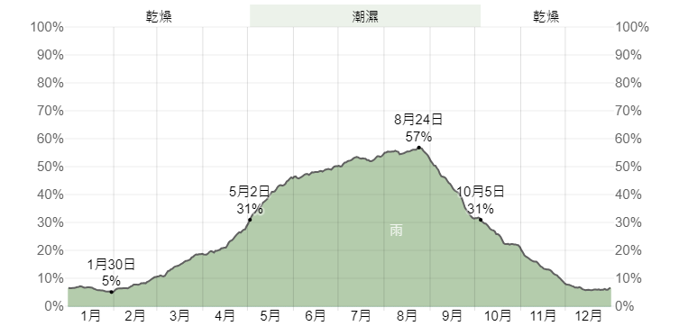

Occupation: Amateur vs Professional
1. Amateurs
Amateurs frequently use screwdrivers for various tasks at home and in their daily lives. These tasks typically involve basic assembly and repair jobs, such as putting together flat-pack furniture, fixing a loose door hinge, or replacing the battery cover on a remote control. The requirements for screwdrivers in this segment are relatively straightforward: the tools need to be easy to use, reliable, and versatile enough to handle a range of minor household tasks. Amateurs value screwdrivers that are ergonomically designed and come with a variety of heads to suit different screw types, as this enhances usability and convenience.
2. Professionals
Professionals, on the other hand, rely on screwdrivers for more demanding and specialized applications across various industries such as construction, manufacturing, agriculture, and fishing. These sectors form the backbone of Vietnam's economy, highlighting the critical importance of durable and high-precision tools in professional settings. In these industries, screwdrivers must not only provide accuracy and flexibility but also withstand the rigors of frequent use and harsh environments. Professional-grade screwdrivers often feature enhanced ergonomics, superior materials, and advanced features such as magnetic tips, torque control, and anti-slip handles. These characteristics ensure that professionals can perform their tasks efficiently, safely, and with a high degree of precision.

3. Difference between Amateurs and Professionals
Given the large working population in Vietnam and the significant employment in the industrial sector, there is a substantial market for professional-grade tools. While amateurs use screwdrivers sporadically for light-duty tasks, professionals use them daily and require tools that can sustain heavy use and deliver consistent performance. Professionals need screwdrivers that offer durability, precision, and comfort over long periods of use. These tools are essential for maintaining productivity and safety in demanding work environments.
Recognizing these distinctions, our marketing strategy will focus on the professional segment. This decision is driven by the greater demand for high-quality, reliable tools in industries that are pivotal to Vietnam's economic growth. By targeting professionals, we can position our products as essential tools that enhance efficiency and reliability in critical sectors such as construction, manufacturing, agriculture, and fishing. This targeted approach will enable us to meet the specific needs of professional users and establish our brand as a trusted provider of top-tier screwdrivers.

Wage range:Low-income
Vietnam has made significant economic progress over the past few decades, transitioning from a centrally planned economy to a socialist-oriented market economy. This transition has led to impressive growth rates and poverty reduction. However, income inequality remains a challenge, with significant disparities between urban and rural areas, as well as among different regions of the country.
Low-income individuals and households in Vietnam often face challenges. They may also have limited opportunities for economic advancement and face barriers to social mobility.
The following picture is 「2022 economic class household distribution」，We can see that there is a gap in income levels between urban and rural areas. In Vietnam, low-income families also account for the majority. High-income families A and B only account for 6% of the total, showing an obvious gap between rich and poor.
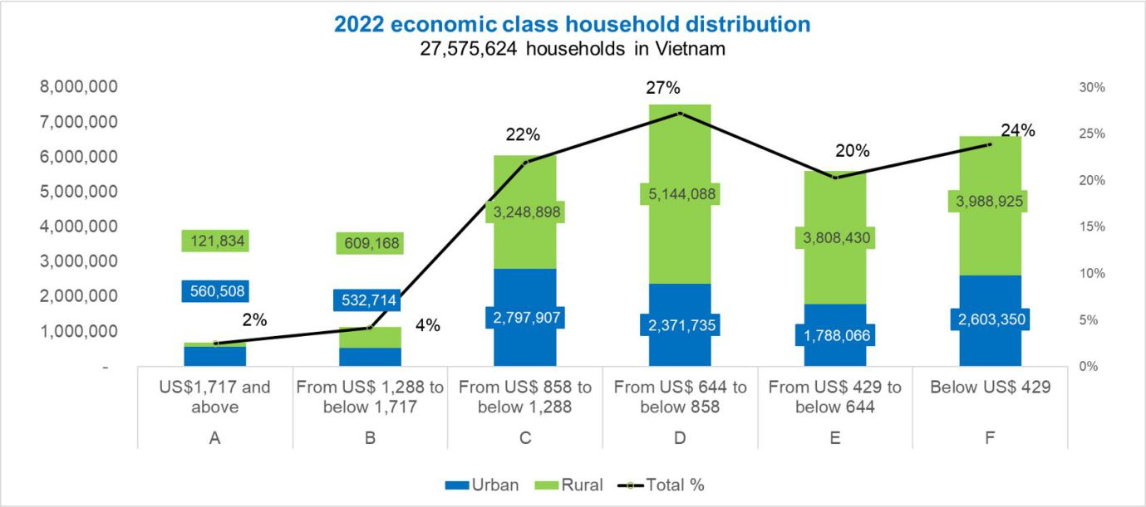

The following picture is 「2022 economic class household distribution in Vietnam」

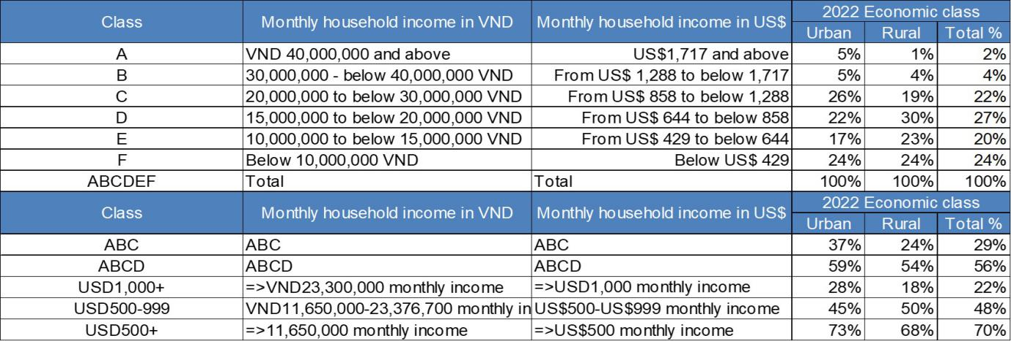

Product

Anti-slip material

Given the high humidity levels, we have opted for non-slip handles to facilitate better force application. The handles are made from 3M™ Gripping Material GM530, which offers superior anti-slip properties even in wet or oily environments. This material is soft to the touch, avoiding any roughness or irritation, and possesses good elasticity, allowing it to closely adhere to curved surfaces. These features ensure a secure grip, enhancing both safety and efficiency during use.

Magnetic front-end
Considering Vietnam's large labor force and the need for cost-effective solutions, we plan to use artificial magnets combined with inexpensive steel. This approach helps reduce costs while maintaining functionality. The front-end of the tool is designed to be detachable, allowing users to exchange it at the company or dealer once the magnetic force diminishes. This not only extends the lifespan of the tool but also provides a practical solution for maintaining performance without significant additional expense.

High-carbon steel
To accommodate the economic constraints faced by many Vietnamese consumers, we have selected high carbon steel as the primary material for our tools. Specifically, we use SM7 for its quenching hardness. High carbon steel offers several advantages: it is hard, cost-effective, and highly wear-resistant. These properties make it an ideal choice for producing durable and affordable tools suitable for the Vietnamese market.

Pricing

Penetration pricing
We will choose to use the method of small profits but quick turnover to expand channels and increase market share. There are two reasons. First, there is a huge demand for industries in Vietnam, so the market demand is high enough. In addition, the average income in Vietnam is low, so they are more sensitive to price changes rather than pursuing brands.

Pricing build strategy
For basic models of manual screwdrivers, the price typically ranges from 20K to 50K VND (about $1 to $2 USD). These screwdrivers are suitable for general household and basic DIY purposes, capable of meeting the needs for everyday repairs and assembly.
For higher quality or well-known brand manual screwdrivers, the price may range from 50K to 200K VND (about $2 to $8 USD). These screwdrivers are usually made from more durable materials and feature more ergonomic designs, making them suitable for individuals who need to use tools frequently.
We decided to price our screwdriver at 17.8K VND( $0.7 USD). Penetrate the market through prices that are cheaper than the average market price, establish a stable customer base, and then increase the price to a profitable price , and we thought that we can get more connection with our labor market.

Position

Product Positioning
Create an impression of worker friendliness, close connection with tools and labor groups, economical and approachable prices.When users talk about our products we hope they will think of us as practical and cheap, and that they will think of us when they think of their preferred screwdriver.

Position map

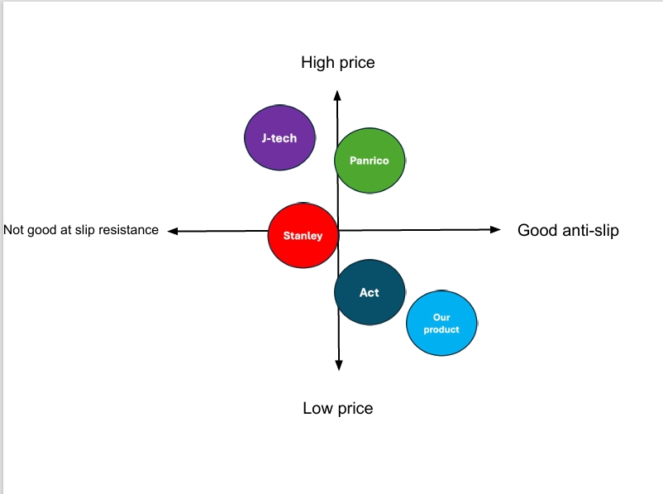

Promotion

Channels
Our screwdrivers are tailored to meet the demands of professionals across various industries, including fisheries, manufacturing, agriculture, and construction. Leveraging a business-to-business (B2B) approach, we aim to distribute our products directly to businesses operating within these sectors.
Through targeted outreach and collaboration with businesses in these sectors, we aim to establish partnerships that streamline access to our products for professional users. By connecting directly with manufacturers, distributors, and contractors, we can ensure that our screwdrivers are readily available to meet the specialized needs of professionals across diverse industries.
- Promotion strategy
Tiktok industry support, since Tiktok is now a world-class platform, we can cooperate with creators. As long as consumers pass the Tiktok platform, they can get additional discounts. The specific discounts will be negotiated between the creators and the company.

Service support – 3Ps

Service
We have established a dedicated Customer Service Department to ensure efficient handling of related inquiries and provide support in various languages. Our professional customer service team serves as a direct channel for swiftly addressing customer concerns and inquiries.
In terms of after-sales service, we prioritize customer satisfaction by offering services such as consumables replacement (e.g., magnetic front ends) and product consultations. This proactive approach aims to prevent any potential loss of customers due to post-purchase issues or concerns.

Service added value
We not only provide the product itself but also offer related accessories and consumables free of charge, ensuring that customers can use our products without additional expenses for accessories or consumables.
Furthermore, we offer extended warranty services to provide customers with prolonged protection. This service is designed to reassure customers that they can receive free repairs or replacements even if the product encounters quality issues or malfunctions. This additional assurance enables customers to confidently choose our products and enhances their trust and satisfaction.
We prioritize communication and engagement with customers, maintaining regular contact and strengthening customer relationship management (CRM). Through consistent communication and CRM practices, we ensure a better understanding of customer needs and feedback. This ongoing dialogue not only helps address any issues customers may encounter but also provides opportunities for us to improve products and services. By establishing close and resilient relationships, we foster higher customer satisfaction and loyalty.

Conclusion
The professional screwdriver market trend in Vietnam underscores the significant demand for high-quality tools tailored for professionals in key industries. By focusing on durability, precision, and comfort, the market aims to meet the intensive usage requirements of professionals. Through the use of materials like high-carbon steel and a penetration pricing strategy, the goal is to expand market share effectively. Service support, including after-sales services, product consultations, and extended warranties, plays a vital role in enhancing customer satisfaction and loyalty.

The geographic and occupational segmentation in Vietnam, influenced by the humid climate, highlights the importance of designing tools that can perform optimally in such conditions. The product features, such as the anti-slip material, magnetic front-end design, and high-carbon steel construction, cater to the economic constraints faced by Vietnamese consumers while ensuring durability and affordability.

The pricing strategy of offering the screwdriver at a competitive price of 17.8K VND ($0.7 USD) aims to penetrate the market, establish a loyal customer base, and gradually increase prices to a profitable level. The positioning strategy focuses on creating a worker-friendly image and fostering a strong connection with labor groups, aligning with the target market's preference for practical and affordable tools.

Promotion channels through a business-to-business (B2B) approach target industries like fisheries, manufacturing, agriculture, and construction, positioning the products as essential tools that enhance efficiency and reliability. Overall, the market trend in Vietnam emphasizes the importance of providing high-quality, cost-effective tools that meet the specific needs of professional users in critical sectors, driving economic growth and productivity.

In conclusion, the professional screwdriver market trend in Vietnam highlights a strong demand for high-quality tools tailored for professionals in key industries. By focusing on durability, precision, and comfort, the market aims to meet the intensive usage requirements of professionals. Through strategic pricing, material selection, and service support, the market seeks to expand its reach and enhance customer satisfaction. Overall, the emphasis on practicality, affordability, and reliability underscores the importance of providing tools that cater to the specific needs of professional users in Vietnam's growing industrial sectors.

Reference
https://taxsummaries.pwc.com/vietnam/individual/taxes-on-personal-income

https://climateknowledgeportal.worldbank.org/country/vietnam/climate-data-historical
https://www.foxwoll.com/blogs/screwdriver-material/
https://ads.tiktok.com/i18n/home
https://www.essentracomponents.com/en-us/news/solutions/access-hardware/low-medium-high-carbon-steel
https://www.amazon.com/Sleeving-Anti-Slip-handles-kitchen-utensils/dp/B09DGK6GWB
https://www.aliexpress.com/item/1005004583115910.html
https://en.wikipedia.org/wiki/Vietnam
https://www.ajmarketing.io/post/top-11-marketing-trends-in-vietnam-for-2022

